The analysis of Resistor Inductor and Capacitor Circuits

Andy Perez

MAE 334 L1

Monday 2-4:20 pm

TA: Junhee Lee

Students in Group 7: Andrew Alegria

Lab 1 RC and RLC Circuit Analysis

1. Abstract

The purpose of this report was to analyze the behavior of Circuits in order to calculate their properties, and see how these properties are affected with respect to the inputs put into the Circuit. The data presented in this report consists of graphs and calculations for Resistor Capacitor Circuits and Resistor Capacitor Inductor circuits. The first part consists of graphs of the voltage sources and input voltages of the Resistor Capacitor Circuit with respect to time, the calculation of the time constant using error fractions and 63.2 percent of the final steady state Voltage input, plots of the error fractions with respect to time, a bode plot of the Resistor Capacitors Transfer function, and a plot of the Simulink results using the transfer function with respect to time. The second part of the data presented deals with the Resistor Capacitor Inductor Circuit, there are graphs of its underdamped and overdamped input voltages and source voltages with respect to time, calculations of the underdamped circuits rising times, settling times, natural frequency, and damping ratio. And a plot of the Simulink results using its transfer function with respect to time. The major conclusions of this report are that the error fraction method is the most accurate when it comes to depending the time constant, the Resistor Capacitor circuit is used as low pass filter for frequencies and filters frequencies over the cut off frequency, the resistance is directly related to the damping ratio in a Resistor Capacitor Inductor Circuit, and that measurement contributes to a difference between experimentally and theoretically calculated values of natural frequency and damping ratio.

1. Introduction

This study was performed in order to better understand the effects that the inputs of a circuit have on its system. The study was also done to see the errors that come about when trying to reproduce systems in real life. There were known general facts coming into the experiment. It is known that RC circuits in series “generally act as low pass filters” [1]. It is known that the RC circuit is a first order system and that the low pass filter is shown on a Bode plot which is derived from the transfer function which depends on the first order equation of the system. It is known that accurate data requires many data points, and is less accurate with less data points. It is known that RLC circuits consist of a “second order equation” [2] and that the Resistance is directly related to the damping ratio. It is known that the damping ratio is one for critically damped, more than one for overdamped, and less than one for underdamped. It is known there is error in measured data when compared to theoretical data. There was some purpose in becoming more familiar with electrical systems. The specific purpose of the study was to learn how to use the best methods to obtain accurate data from a system and how error is accounted for in these methods by enacting multiple trials, using different methods, and comparing to the theoretical results of the system.

3. Experimental Methods

The materials used were a data acquisition board, wires, a desktop computer with a LabVIEW program, a resistance decade box, a capacitance decade box, an inductor decade box, and a multimeter. The wires were used to connect the electronics with each other in a series circuit. The desktop computer with the LabVIEW Program was used to monitor the voltage source and inputs with respect to time. The resistance decade box was used to set a resistance, the capacitance decade box was used to set a capacitance, and the inductor decade box was used to set an inductance. The data acquisition board provided the Source Voltages and input Voltages since it had ports open to wires. The multimeter was used to measure the actual resistance, capacitance, and inductance that was being put out, since there was some error.

For the first part a Resistor Capacitor Circuit in series was set up. Wires were set up for the data acquisition board they were put into outlets that were defined as the Voltage Source and Voltage input. The positive Voltage Source was wired to the resistance decade box and the resistance decade box’s other port was wired to the Capacitance decade box on top of a wire that was connected to the positive Voltage input. The other port of the Capacitance decade box was wired to the negative Voltage Source and on top of that it was wired to the negative Voltage input. Then the desired capacitance and Resistance was set on the decade boxes. Afterwards the multimeter was used to measure the actual resistance and Capacitance. The simulation was then set up for the required Sampling Rate. Finally, the simulation was run and the input Voltages and Voltage sources with respect to time were recorded for 3 trials. A Resistor Capacitor circuit in series is shown below.

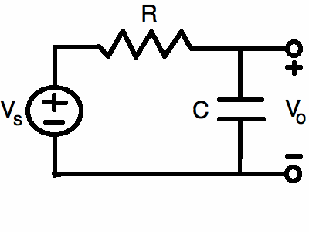

The Resistor Capacitance circuit in series was taken apart in order to set up a Resistor Capacitor Inductor circuit in Series. The data acquisition board was set up as before but this time its wires for the Voltages were connected differently. The Voltage wires are still set up as before but now there is a wire connecting the Resistance Decade box and the Inductor decade box, and a wire connecting the Inductor decade box to the Capacitance Decade box. Then the Capacitance, Inductance and Resistance are set. Afterwards the actual Resistance, Capacitance, and Inductance are measured including the Resistance the Inductor outputs. The simulation is set at the desired sampling rate. Then 3 simulations are run for the circuit and the data is recorded, the data consists of Input Voltages and Source Voltages with respect to time. Afterwards a new resistance is calculated and set for an overdamped circuit and a simulation is run for that overdamped circuit. The overdamped circuits input voltages and source voltages with respect to time are recorded. Below is a Resistor Inductor Capacitor Circuit in series.

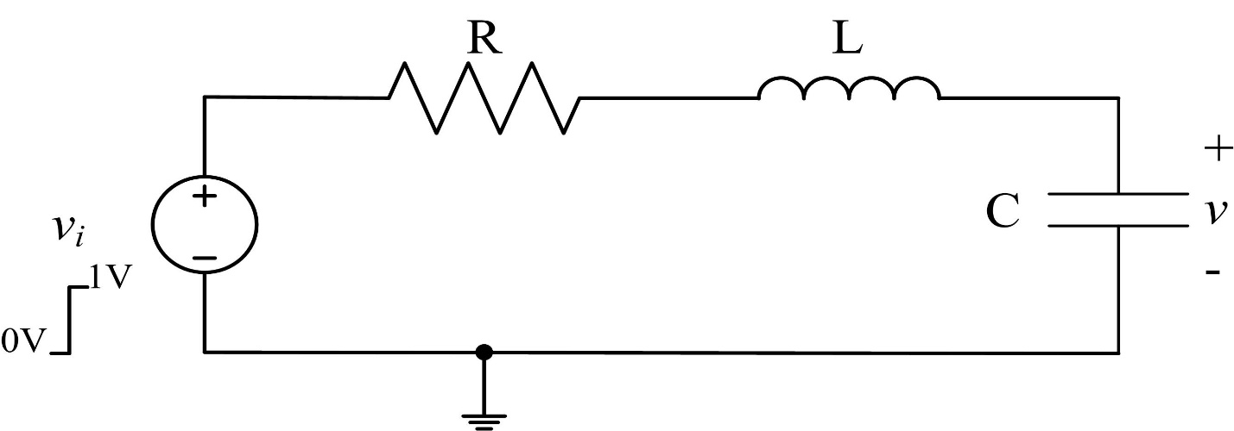

This circuit design and analysis was done in a lab on the 6th floor of Furnas Hall on a Monday during 2:00-4:20 pm.

Programming

load('vc1') load('vs1') load('vc2') load('vs2') load('vc3') load('vs3') load('vcrlc1') load('vsrlc1') load('vcrlc2') load('vsrlc2') load('vcrlc3') load('vsrlc3') load('vcdamp') load('vsdamp') t=.0001:.0001:(80000\*.0001); figure plot(t,vs1,t,vc1) legend('vs1','vc1') title('rc1') xlabel('t(seconds)') ylabel('Voltage') %figure

%plot(t(74810:75300),vs1(74810:75300),t(74810:75300),vc1(74810:75300)) %legend('vs1','vc1') tau1=7.48955-7.482 figure plot(t,vs2,t,vc2) legend('vs2','vc2') title('rc2') xlabel('t(seconds)') ylabel('Voltage') %figure

%plot(t(65290:65800),vs2(65290:65800),t(65290:65800),vc2(65290:65800)) %legend('vs2','vc2') tau2=6.5376-6.53 figure plot(t,vs3,t,vc3) legend('vs3','vc3') title('rc3') xlabel('t(seconds)') ylabel('Voltage') %figure

%plot(t(57130:57700),vs3(57130:57700),t(57130:57700),vc3(57130:57700)) %legend('vs3','vc3') tau3=5.7217-5.714 error1=(vc1-mean(vc1(75300:80000)))/(mean(vc1(1:74810))(mean(vc1(75300:80000)))); error2=(vc2-mean(vc2(65800:80000)))/(mean(vc2(1:65290))(mean(vc2(65800:80000)))); error3=(vc3-mean(vc3(57700:80000)))/(mean(vc3(1:57130))(mean(vc3(57700:80000)))); figure

plot(t(74810:75300),error1(74810:75300)) title('error 1') xlabel('t(seconds)') ylabel('error fraction') hold on b1=((t(74810:75300))')\(error1(74810:75300)); error11=b1\*(t(74810:75300)); plot((t(74810:75300)),error11) legend('error fraction','linear regression') figure plot(t(65290:65800),error2(65290:65800)) title('error 2') xlabel('t(seconds)') ylabel('error fraction') hold on b2=((t(65290:65800))')\(error2(65290:65800)); error22=b2\*(t(65290:65800)); plot((t(65290:65800)),error22) legend('error fraction','linear regression') figure plot(t(57130:57700),error3(57130:57700)) title('error 3') xlabel('t(seconds)') ylabel('error fraction') hold on b3=((t(57130:57700))')\(error3(57130:57700)); error33=b3\*(t(57130:57700)); plot((t(57130:57700)),error33) legend('error fraction','linear regression') %b3= tau11=-(t(75300)-t(74810))/(log(error1(75300))-log(error1(74810))) tau22=-(t(65800)-t(65290))/(log(error2(65800))-log(error2(65290))) tau33=-(t(57700)-t(57130))/(log(error3(57700))-log(error3(57130))) R=55800; C=141.6\*10^-9; figure plot(t,TFrc(:,1),t,TFrc(:,2)) legend('vs','vc') title('rc tf') xlabel('t(seconds)') ylabel('Voltage')

H=tf([1],[R\*C 1]); figure bode(H) t2=.00004:.00004:(150000\*.00004); figure plot(t2,vsrlc1,t2,vcrlc1) legend('vs','vc') title('rcl1') xlabel('t(seconds)') ylabel('Voltage') figure plot(t2,vsrlc2,t2,vcrlc2) legend('vs','vc') title('rcl2') xlabel('t(seconds)') ylabel('Voltage') figure plot(t2,vsrlc3,t2,vcrlc3) legend('vs','vc') title('rcl3') xlabel('t(seconds)') ylabel('Voltage') figure plot(t2,vsdamp,t2,vcdamp) legend('vs','vc') title('rcldamp') xlabel('t(seconds)') ylabel('Voltage') R2=359.3+154.7;

C2=143.6\*10^-9; L2=470\*10^-3; wn=1/((L2\*C2)^.5) dampratio=(R2/2)\*((C2^.5/L2^.5)) S=stepinfo(vcrlc1,t2,1)

S2=stepinfo(vcrlc2,t2,1) S3=stepinfo(vcrlc3,t2,1) figure plot(t2,TFrcl(:,1),t2,TFrcl(:,2)) legend('vs','vc') title('rcltf') xlabel('t(seconds)') ylabel('Voltage')

4. Results

*tau1 = 0.0076*

*tau2 = 0.0076*

*tau3 = 0.0077*

*tau11 = 0.0079*

*tau22 =*

*0.0079*

*tau33 = 0.0077*

*wn = 3.8492e+03*

*dampratio = 0.1421*

*S =*

*RiseTime: 2.8911e-04*

*SettlingTime: 5.4006*

*SettlingMin: 0.6096*

*SettlingMax: 1.6237*

*Overshoot: 62.3674*

*Undershoot: 0.1079*

*Peak: 1.6237*

*PeakTime: 5.3949*

*S2 =*

*RiseTime: 2.8919e-04*

*SettlingTime: 5.5509*

*SettlingMin: 0.6099*

*SettlingMax: 1.6234*

*Overshoot: 62.3350*

*Undershoot: 0.1079*

*Peak: 1.6234*

*PeakTime: 5.5452*

*S3 =*

*RiseTime: 3.2575e-04*

*SettlingTime: 5.4350*

*SettlingMin: 0.8397*

*SettlingMax: 1.3998*

*Overshoot: 39.9827*

*Undershoot: 0.1079*

*Peak: 1.3998*

*PeakTime: 5.4323*

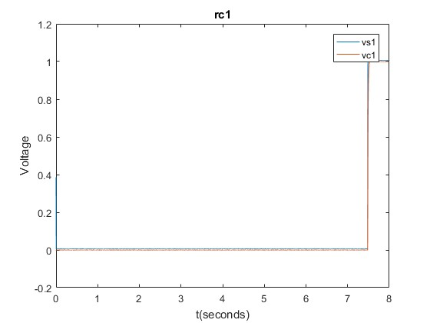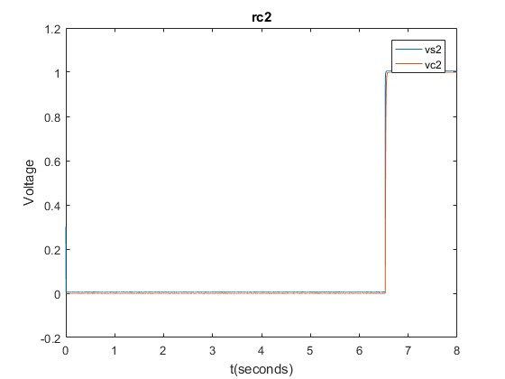

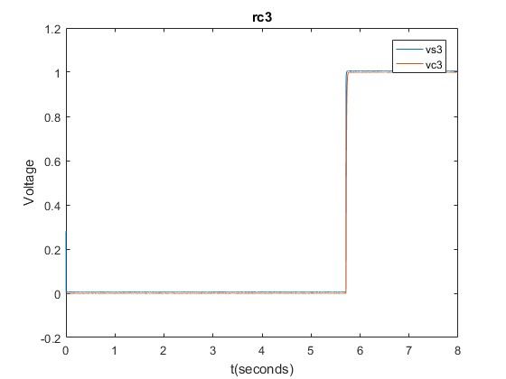







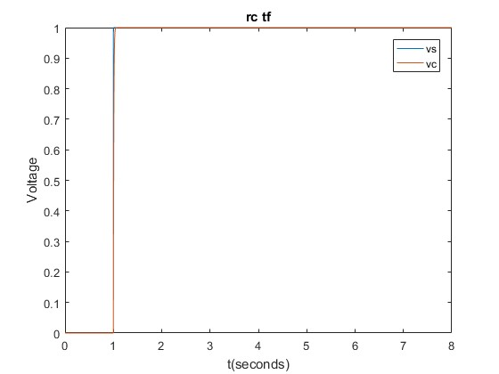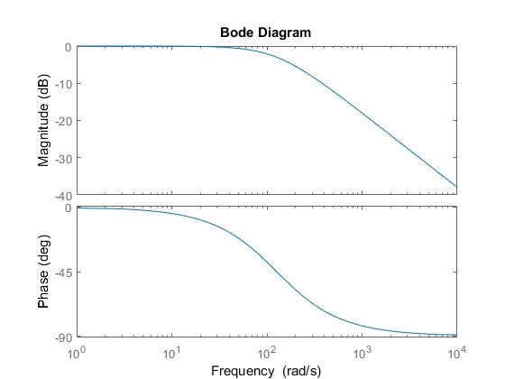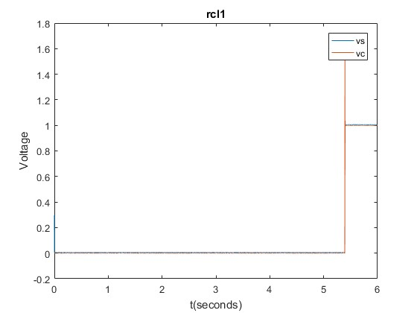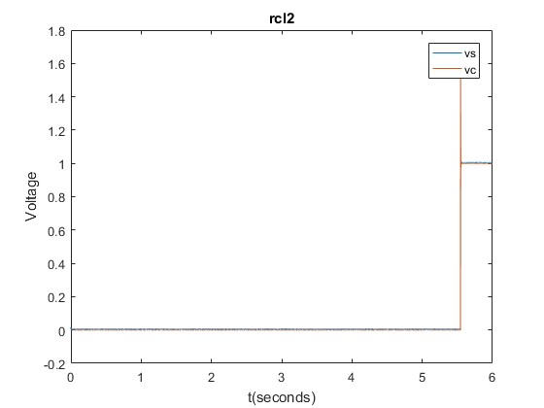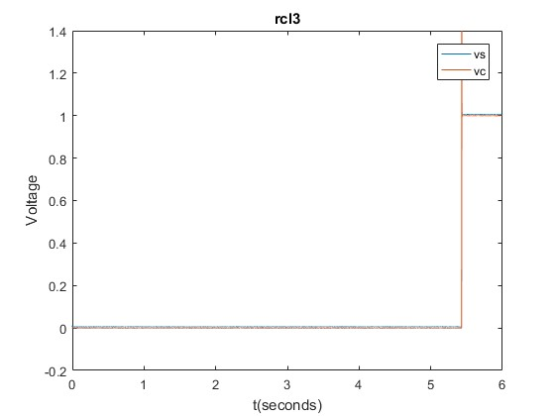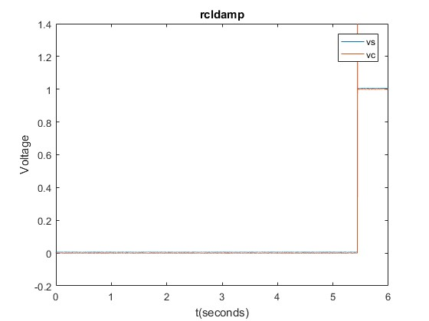

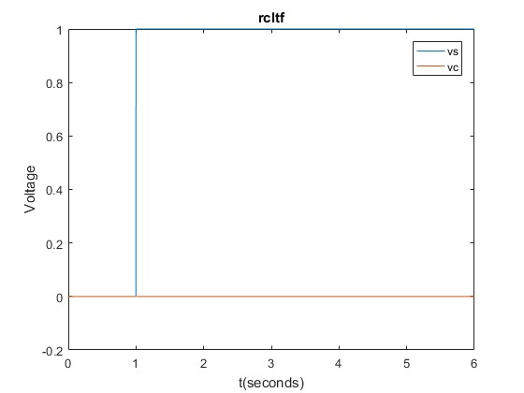

*Published with MATLAB® R2016a*

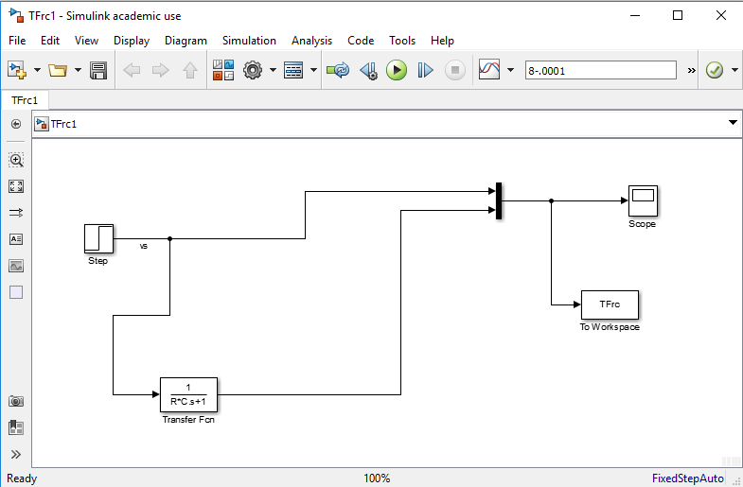

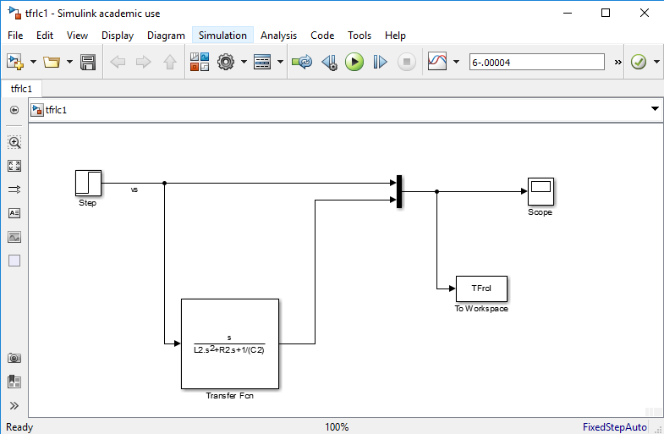

5. Discussion

5.1 1) How do your experimentally determine values of τ compare with each other? Do you think one method should be more accurate than the other? How do the values compare with the theoretically expected value of τ=RC?

1)The value of the time constant is determined by two methods and since there are three trials for the Resistor Capacitor circuit in series there are 6 determined time constants. The first method used to calculate the time constant consists of taking the difference between the time at 63.2 percent of the final steady state voltage input value and the time at when the Voltage input starts to depart from its initial transient response. The second method of calculating the time constants requires more steps, it is the error fraction method. First the average is calculated for the transient and final steady state input voltage responses, then the difference between the average of the final steady state and all the input voltages is divided by the difference of the average of the transient and final steady state input voltages. After all those steps the results is the error fraction. We use the data from the error fraction that contributes to a slope. We find the slope from the natural logarithm of the error fraction data points and divide -1 by that slope, this results in the time constant. The error fraction method produces time constants that are near the 1st methods results but are generally a bit larger. The error fraction method should be more accurate because unlike the 1st method, it does not depend on only one data point, it depends on multiple data points. The theoretically expected value of the time constant is 0.0079, the first method produces time constants of values 0.0076,0.0076, and 0.0077. The second method produces time constants of values 0.0079,0.0079, and 0.0077. The second method produces more accurate results in this case, but the first methods values are not far off.

2) Referencing the Bode plot, discuss how the RC circuit is used as a low-pass filter. What frequencies, in Hz, would your RC-circuit filter?

The RC circuit is used as a low pass filter because of the way it “treats the signals that come in at below and above the cutoff frequency” [ 1]. The cutoff frequency is calculated in rad/s by “dividing 1 by the time constant” [1]. The cutoff frequency is 127 rad/s or 20.2 Hz and below that frequency signals are passed, but above that frequency signals are reduced in intensity, as seen by the Bode plot. In the Bode plot the magnitude of increasing frequency decreases by 20 decibels per decade after the cutoff frequency is passed. It filters those frequencies that are higher than the cutoff frequency, higher than 127 rad/s or 20.2 Hz.

5.2

3) How did you determine an appropriate 𝑅 value for the overdamped case? For what value of R would the system be critically damped?

First the relationship between the Resistance and the damping ratio had to be determined, then the resistance had to be adjusted in order to achieve an overdamped system. An overdamped system is a system in where the damping ratio is more than one. The relationship was found due to the knowledge that the Resistance Inductor Capacitor circuit was a 2nd order equation where the natural frequency and damping ratio were used to create that 2nd order equation The relationship was found to be the damping ratio equals the Resistance over 2 multiplied by the square root of the Capacitance over the Inductance, a direct relationship. In the mentioned equation the Resistance is the sum of the Resistance due to the Resistor and Inductor. The R for the overdamped case was just the Resistance for the resistor. To find R the inductors resistance had to be subtracted from the overall resistance. In order to find R for where the system is critically damped the damping ratio has to be one and the overall resistance has to be subtracted by the resistance due to the inductor. The value of the overall resistance is 3618 ohms and the value of R would be 3464 ohms.

4) How do your experimentally determine values of Natural Frequency, 𝜔𝑛, and the Damping Ratio, ζ (zeta) compare with the theoretically predicted values? Discuss possible causes of differences between theoretical values and measured values.

The theoretically predicted value of the natural frequency is 4030 and the experimentally predicted value was 3850. The experimentally predicted value of the damping ratio was 0.1421 and the theoretically predicted value is 0.145. The experimentally predicted values were lower than the theoretical value. The possible causes of differences may be due to the fact that the theoretical values assume there is no error when setting the decade boxes to a certain value, but there was some error in all the decade boxes, and these errors manifest themselves in the calculations that use the measured values.

6. References

[1] <http://www.electronics-tutorials.ws/filter/filter_2.html>

[2] http://www.alab.ee.nctu.edu.tw/wpmu/ckt/files/2012/09/Second-Order-Circuits.pdf